PROJECT REPORT
ON
“IMPLEMENTATION OF A MULTI-DEPTH SOIL NUTRIENT PROFILING SYSTEM WITH EDGE-ADAPTIVE FERTIGATION CONTROL”
Submitted in partial fulfilment of the requirements for the V semester
Mini Project Work [213ECE2442]
BACHELOR OF TECHNOLOGY
in
ELECTRONICS AND COMMUNICATION ENGINEERING
Of
Kalasalingam Academy of Research and Education
Submitted by
M BHUVANESHWARI – 9924005212
VIDYASRI K S – 9924005364
ALTHAF PAKEER MYDEEN S – 9924005467
RAM GOPAN G C – 9924005346

Mr. Bhargav Prof. Mrs. Loyola Jasmine
External guide Internal Guide
Senior Design Engineer Assistant Professor
Company- Simask Pvt Ltd Dept. of ECE, KARE

DEPARTMENT OF ELECTRONICS AND COMMUNICATION ENGINEERING
KALASALINGAM ACADEMY OF RESEARCH AND EDUCATION
ACADEMIC YEAR 2026–2027

KALASALINGAM ACADEMY OF RESEARCH AND EDUCATION
Krishnankoil, Srivilliputhur, Tamil Nadu 626126
Department Of Electronics And Communication Engineering
CERTIFICATE
It is Certified that Ms. M Bhuvaneshwari, Ms. K S Vidyasri, Mr. Althaf Pakeer Mydeen S, Mr. Ram Gopan bearing REG NUM: 9924005212, 9924005364, 9924005467, 9924005346 respectively, are bonafide students of Kalasalingam Academy of Research and Education, and have completed requirements of the project entitled “Implementation of a Multi-Depth Soil Nutrient Profiling System with Edge-Adaptive Fertigation Control ” partial fulfillment of the requirements for V semester Bachelor of Engineering in Electronics and Communication Engineering during academic year 2026-27. It is certified that all Corrections/Suggestions indicated for Project Assessment have been incorporated in the report. The project report has been approved as it satisfies the academic requirements in respect of project work Phase-2 prescribed for the Bachelor of Engineering degree.

Mr. Bhargav Prof. Mrs. Loyola Jasmine
External guide Internal Guide
Senior design engineer Assistant Professor
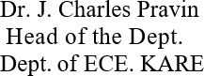
Company- Simask Pvt Ltd Dept. of ECE, KARE
External Viva
Name of the Examiners Signature with date

DECLARATION

It is Certified that Ms. M Bhuvaneshwari, Ms. K S Vidyasri, Mr. Althaf Pakeer Mydeen S, Mr. Ram Gopan bearing REG NUM: 9924005212,9924005364, 9924005467,9924005346 respectively, are bonafide students of Kalasalingam Academy of Research and Education, and have completed requirements of the project entitled “Implementation of a Multi-depth Soil nutrient profiling system with Edge-Adaptive Fertigation control” partial fulfillment of the requirements for V semester Bachelor of Technology in Electronics and Communication Engineering during academic year 2026-27.
We also declare that, to the best of our knowledge and belief, the work reported here does not form part of any other report on the basis of which a degree or award was conferred on an earlier occasion on this by any other student.

Date: ____________________
Place: ___________________

Signature of the Students

ABSTRACT
Agricultural productivity depends not only on the availability of water but also on soil conditions and the availability of essential nutrients. Conventional irrigation practices often rely on fixed schedules or surface-level observations, which may not accurately represent variations in soil moisture at different root-zone depths. This can result in inefficient water utilization and inadequate understanding of soil conditions.
This project presents the implementation of a Multi-Depth Soil Nutrient Profiling System with Edge-Adaptive Irrigation Control. The system monitors soil moisture at multiple depths to identify variations in moisture conditions across the root zone. An RS485-based NPK sensor is incorporated to measure the major soil nutrients, namely Nitrogen, Phosphorus and Potassium. Three DS18B20 temperature sensors are also included to monitor soil temperature.
An STM32 microcontroller acts as the primary edge controller, responsible for sensor data acquisition, local processing and threshold-based irrigation decisions. Based on the measured soil moisture values and configured threshold limits, the controller operates a relay module to control the water pump automatically. This enables irrigation decisions to be made locally without depending on continuous internet connectivity.
An ESP32 Wi-Fi module is integrated as the communication unit. It receives the processed sensor data from the STM32 through UART communication and provides wireless monitoring through an HTTP-based web dashboard. The dashboard displays soil moisture, temperature, NPK readings and system status, allowing users to observe soil conditions remotely.
The proposed system combines multi-depth soil monitoring, embedded edge processing and automatic irrigation to improve water management and support precision agriculture. The system focuses on automated irrigation while providing NPK measurements for soil nutrient assessment and informed fertilizer-management decisions.
Keywords: Smart Agriculture, Multi-Depth Soil Monitoring, Soil Moisture, NPK Sensor, STM32, ESP32, Edge Computing, Automatic Irrigation, IoT, Precision Agriculture.
TABLE OF CONTENTS
Chapter | Title
Chapter 1 | Introduction
Chapter 2 | Problem Study and Existing Practices
Chapter 3 | System Requirements and Proposed Architecture
Chapter 4 | Literature Survey
Chapter 5 | Proposed Methodology
Chapter 6 | Hardware and Software Implementation
Chapter 7 | Edge-Adaptive Fertigation Algorithm
Chapter 8 | Testing, Results and Discussion
Chapter 9 | Conclusion and Future Scope
Chapter 10 | References

CHAPTER 1

INTRODUCTION

Introduction
Agriculture plays a vital role in ensuring food security and supporting economic development. Crop productivity depends on several factors, including soil moisture, nutrient availability, soil temperature and other environmental conditions. However, conventional irrigation methods often rely on fixed schedules and manual observations, which may not accurately represent the actual soil conditions at different root-zone depths. This can lead to inefficient water utilisation and inadequate understanding of soil moisture and nutrient variations.
To address these limitations, this project presents the Implementation of a Multi-Depth Soil Nutrient Profiling System with Edge-Adaptive Irrigation Control. The system is designed to monitor soil conditions at multiple depths within the crop root zone rather than depending only on surface-level measurements. It uses soil moisture sensors to measure moisture variations at different depths, an RS485-based NPK sensor to measure Nitrogen, Phosphorus and Potassium levels, and three DS18B20 temperature sensors to monitor soil temperature.
The system uses an STM32 microcontroller as the primary edge controller for sensor data acquisition, local processing and decision-making. The collected soil moisture readings are evaluated against predefined threshold values to determine irrigation requirements. Based on these decisions, the STM32 controls a relay module to operate the water pump automatically. An ESP32 module provides Wi-Fi connectivity and receives sensor data from the STM32 through UART communication. It makes the collected information available through an HTTP-based web dashboard for remote monitoring of soil conditions and system status.
The edge-adaptive approach enables essential irrigation decisions to be made locally without depending entirely on continuous internet connectivity. By integrating multi-depth soil monitoring, nutrient profiling, embedded processing and automatic irrigation, the system aims to improve water utilization, provide better insight into soil nutrient conditions and promote sustainable precision agriculture.

Background
Agriculture requires careful management of water and nutrients to maintain healthy crop growth. Soil conditions are not uniform throughout a field. Soil moisture and nutrient availability can vary with depth, irrigation history, soil texture and crop uptake. Measurements taken only near the surface may therefore fail to represent the conditions experienced by plant roots at deeper levels.
Smart agriculture uses sensors, embedded controllers and communication technologies to improve agricultural monitoring and management. By collecting soil measurements at different depths and processing them locally, a monitoring system can provide a better understanding of the root-zone environment. This information helps farmers make informed decisions regarding irrigation and soil nutrient management, supporting efficient water utilization and sustainable agricultural practices.
1.3 Problem Statement
Conventional irrigation practices often depend on fixed watering schedules, manual inspection or a limited number of surface-level soil measurements. These methods may not accurately represent variations in soil moisture at different root-zone depths. As a result, irrigation may not correspond to the actual water requirements of the soil, leading to unnecessary water consumption.
Furthermore, limited information about soil nutrient levels makes it difficult to assess the nutrient status of the root zone. A compact monitoring system is therefore required to measure soil moisture at multiple depths, monitor NPK levels and soil temperature, and use the collected information to support better agricultural decisions.
The project addresses this problem through STM32-based local processing and automatic irrigation control, together with ESP32-based wireless monitoring.
1.4 Objectives
- To develop a multi-depth soil monitoring system for observing variations in soil conditions across the root zone.
- To measure soil moisture at different depths using soil moisture sensors.
- To monitor soil nutrient levels using an RS485-based NPK sensor.
- To measure soil temperature at different depths using three DS18B20 sensors.
- To implement an STM32-based edge controller for sensor data acquisition, local processing and threshold-based irrigation decisions.
- To develop an automatic irrigation mechanism using a relay-controlled water pump based on soil moisture conditions.
- To integrate an ESP32 Wi-Fi module for wireless data communication and remote monitoring through an HTTP-based web dashboard.
- To evaluate the system through sensor testing, actuator response tests and controlled soil trials.

1.5 Scope of the Project
The project focuses on developing a prototype multi-depth soil monitoring system with edge-based automatic irrigation. It includes soil moisture measurement at multiple depths, NPK monitoring through an RS485-based sensor and soil temperature measurement using three DS18B20 sensors.
The STM32 microcontroller is responsible for sensor data acquisition, local processing and irrigation decisions based on configured moisture thresholds. A relay module is used to operate the DC water pump automatically. The ESP32 receives sensor data from the STM32 through UART communication and provides Wi-Fi connectivity for transferring monitoring information to Firebase Realtime Database.
A web-based dashboard is developed to display the latest soil moisture, temperature, NPK measurements and irrigation status. The scope includes embedded programming, sensor interfacing, local irrigation control, wireless communication, database integration and dashboard development.
NPK readings are used for soil nutrient assessment and do not directly control fertilizer dispensing. Automatic fertilizer application and pH monitoring are outside the current implementation scope

CHAPTER 2

PROBLEM STUDY AND EXISTING PRACTICES
2.1 Soil Variability Across Depth
Soil conditions are not uniform throughout the soil profile. Moisture content and temperature may vary between the upper, middle and lower soil layers due to sunlight exposure, environmental conditions, water movement and soil characteristics. Surface soil generally loses moisture more quickly, while deeper layers may retain moisture for longer periods.
Monitoring soil conditions at multiple depths provides a better understanding of moisture distribution across the crop root zone. In this project, three soil moisture sensors and three DS18B20 temperature sensors are used to observe variations at different soil levels. An RS485-based NPK sensor is also incorporated to monitor the major soil nutrients: Nitrogen, Phosphorus and Potassium. This approach provides more information about soil conditions compared to conventional monitoring methods that depend on a single surface-level measurement.
2.2 Conventional Irrigation Practices
In conventional irrigation practices, water is generally supplied at fixed time intervals or based on manual observation of soil dryness. Farmers often depend on experience and visual inspection to determine when crops require water. However, these methods may not accurately represent the moisture conditions at different soil depths.
Fixed irrigation schedules may result in unnecessary water usage when the soil already contains sufficient moisture. Similarly, insufficient irrigation may occur when deeper soil layers require additional water. A sensor-based irrigation system can overcome these limitations by monitoring soil moisture conditions and supporting more suitable irrigation decisions.
2.3 Need for Multi-Depth Soil Monitoring
Monitoring soil moisture at a single depth may not provide sufficient information about the overall soil condition. Moisture levels can differ between the upper, middle and lower soil layers. Therefore, monitoring multiple depths is important for understanding water distribution within the crop root zone.
The proposed system uses three soil moisture sensors to measure moisture variations at different depths. Three DS18B20 temperature sensors provide corresponding soil temperature measurements. An RS485-based NPK sensor measures the major soil nutrient levels, providing additional information about soil fertility.

The collected measurements help analyse soil conditions and provide useful information for irrigation management and nutrient assessment. By combining multiple sensor readings, the proposed system offers a more comprehensive approach to soil monitoring.
2.4 Need for Edge-Adaptive Irrigation Control
Conventional irrigation systems often depend on manual operation or predefined watering schedules. These methods may not respond effectively to changing soil moisture conditions. An automated control system is therefore required to make irrigation decisions based on actual sensor measurements.
The proposed system uses an STM32 microcontroller as the primary edge controller for collecting and processing sensor data. It evaluates the soil moisture readings against predefined threshold values and determines whether irrigation is required. Based on this decision, the relay module controls the DC water pump to supply water automatically. This local decision-making approach allows irrigation control without depending on continuous internet connectivity.
The ESP32 module provides Wi-Fi connectivity and receives sensor data from the STM32 through UART communication. It makes the collected measurements and system information available through an HTTP-based web dashboard for remote monitoring. The integration of local processing, automatic irrigation and wireless monitoring supports efficient water management and precision agriculture.

2.5 Proposed Improvement

The proposed system improves conventional irrigation practices through multi-depth soil monitoring, embedded data processing and automated water control.
Existing Practices | Proposed System
Single-level or manual soil moisture observation | Monitoring using three soil moisture sensors at different depths
Limited temperature monitoring | Temperature measurement using three DS18B20 sensors
Manual irrigation operation | Automatic pump control using STM32 and relay
Fixed irrigation schedules | Irrigation decisions based on measured soil moisture values
Limited soil condition monitoring | Combined monitoring of soil moisture, temperature and NPK parameters
Manual observation of irrigation status | Wireless monitoring using ESP32

The proposed system aims to improve irrigation management by combining multiple soil measurements with local controller-based decision-making. It provides a practical approach to monitoring soil conditions and controlling water delivery according to the measured moisture requirements.

CHAPTER 3

SYSTEM REQUIREMENTS AND PROPOSED ARCHITECTURE

3.1 System Overview
The proposed system is organized into four main functional blocks: multi-depth soil sensing, edge processing, automatic irrigation control and IoT-based monitoring. Sensors installed at different soil depths collect information about soil moisture, temperature and nutrient levels. The collected sensor data is processed by an STM32 microcontroller, which acts as the primary edge controller.
The STM32 evaluates the soil moisture readings against predefined threshold values to determine irrigation requirements. Based on the decision, it operates a relay module to control the water pump automatically. An ESP32 module acts as the communication unit, receiving sensor data from the STM32 through UART communication and transmitting the information through Wi-Fi. An HTTP-based web dashboard displays the collected soil measurements and system status for remote monitoring.
The system combines local decision-making and wireless monitoring to improve irrigation management without depending entirely on continuous internet connectivity.

3.2 Functional Blocks

Block | Main function
Multi-depth sensing | Collect soil-moisture readings from the selected depth levels.
Nutrient and soil-quality sensing | Acquire NPK, moisture and temperature readings using the selected sensor modules.
Edge controller | Read sensors, filter values, apply decision rules and manage actuator outputs.
Communication unit | Send measurements and status information to a remote interface when connectivity is available.
Actuation stage | Operate the water pump automatically through a relay module based on the STM32 irrigation decision.
Dashboard | Display soil readings, operating state, alerts and historical trends.

3.3 Proposed Controller Arrangement

The proposed design uses an STM32 microcontroller as the main controller for deterministic sensor acquisition and local control. An ESP32 may be connected as a communication companion for Wi-Fi-based data transfer. The exact division of work between the two controllers should be confirmed against the implemented firmware. Sensor interfaces may include ADC for analog sensors, UART/RS485 for the NPK module and digital GPIO for actuator control.

3.4 Sensor Description

3.4.1 STM32 Microcontroller

The STM32 microcontroller acts as the primary processing unit of the proposed system. It collects data from the connected soil sensors, processes the measured parameters, and performs local decision-making. Based on the sensor readings and predefined threshold values, it controls the irrigation and fertigation operations. Its processing capabilities make it suitable for implementing edge-based control.

3.4.2 ESP32 Wi-Fi Module

The ESP32 is used as a wireless communication module in the proposed system. It transfers the collected soil parameters and system status to a remote monitoring dashboard through Wi-Fi connectivity. This allows users to monitor soil conditions and irrigation activities remotely.

3.4.3 Capacitive Soil Moisture Sensor

Soil moisture sensors are used to measure the water content present in the soil. In this project, multiple sensors are placed at different soil depths to monitor moisture variations across the crop root zone. The collected readings help the controller determine whether irrigation is required.

3.4.4 RS485 NPK Sensor

The NPK sensor measures the three major nutrients required for plant growth: Nitrogen (N), Phosphorus (P), and Potassium (K). It communicates with the controller through an RS485 interface. The measured nutrient values provide useful information about soil nutrient conditions and support appropriate fertigation decisions.

3.4.5 Temperature Sensors (DS18B20 – 3 Units)

The DS18B20 is a digital temperature sensor used to measure temperature at different soil depths. Three DS18B20 sensors can be installed at selected depth levels to observe temperature variations across the soil profile. These measurements provide additional information about soil conditions and help the controller analyse temperature changes along with moisture readings

3.4.6 Relay Module

The relay module acts as an electrically controlled switching device. It allows the microcontroller to control external devices such as water pumps and solenoid valves. It provides an interface between the low-voltage controller signals and the actuator power circuits.

3.4.7 Power Supply

The power supply provides the required electrical energy to the microcontrollers, sensors, communication modules, and actuators. Appropriate voltage and current ratings are selected based on the requirements of each component to ensure reliable system operation

3.5 Communication
The ESP32 can provide Wi-Fi connectivity for transmitting selected measurements to a monitoring interface. MQTT or HTTP may be used depending on the implemented software. Local sensing and control should remain functional if the network becomes unavailable.

3.6 Design Requirements
- Sensor readings should be associated with their corresponding depth and timestamp.
- Control thresholds should be configurable and selected for the crop and soil under study.
- Pump and valve outputs should have safe default states during reset or sensor failure.

CHAPTER 4

LITERATURE SURVEY
Research in precision agriculture has explored the use of soil sensors, wireless sensor networks and automated irrigation controllers to improve the timing of agricultural operations. The following themes provide the technical background for the proposed system. The final submitted report should include verified bibliographic details for the specific papers and datasheets consulted by the team.

4.1 IoT-Based Smart Agriculture
IoT-based agriculture systems connect field sensors to embedded controllers and communication networks. They allow soil and environmental parameters to be observed more frequently than manual inspection alone. A remote interface can help users review trends and receive alerts, while the controller performs local tasks.

4.2 Soil Moisture Monitoring
Soil-moisture sensing is widely used in automated irrigation. A single sensor can indicate the condition near its installation point, but multi-depth sensing provides additional information about moisture distribution within the root zone. Sensor calibration and installation conditions remain important for obtaining meaningful values.

4.3 Nutrient and Soil-Quality Measurement
NPK, pH and EC measurements are used to understand different aspects of soil condition. NPK sensors estimate selected nutrient parameters, pH indicates acidity or alkalinity, and EC indicates the ability of the soil solution to conduct electrical current. These measurements can support decisions, but they require careful calibration and interpretation.

4.4 Edge Computing in Agriculture
Edge computing places data processing close to the sensors. This reduces the need to transmit every raw reading to a remote server before a decision can be made. In irrigation systems, local threshold checks and safety interlocks can continue during temporary network interruptions.

4.5 Adaptive Fertigation
Fertigation combines fertilizer delivery with irrigation water. The amount and timing should depend on crop requirements, soil characteristics, water quality and agronomic guidance. An embedded controller can automate the delivery sequence, but fertilizer concentration and dosing limits must be established using validated agronomic recommendations rather than arbitrary sensor thresholds.

4.6 Research Gap
Many low-cost prototypes focus mainly on surface moisture and pump switching. The proposed work brings together multi-depth soil observation, nutrient-related sensing and local adaptive control in a single prototype. Its contribution is the integration of these functions into a practical embedded architecture; the actual performance advantage must be established through testing.

CHAPTER 5

PROPOSED METHODOLOGY
5.1 System Overview
The proposed system is organized into four main functional blocks: multi-depth soil sensing, edge processing, automatic irrigation control and IoT-based monitoring. Sensors installed at different soil depths collect information about soil moisture, temperature and nutrient levels. The collected sensor data is processed by an STM32 microcontroller, which acts as the primary edge controller.
The STM32 evaluates the soil moisture readings against predefined threshold values to determine irrigation requirements. Based on the decision, it operates a relay module to control the water pump automatically. An ESP32 module acts as the communication unit, receiving sensor data from the STM32 through UART communication and providing Wi-Fi connectivity. An HTTP-based web dashboard displays the collected soil measurements and irrigation system status for remote monitoring.The system combines local decision-making and wireless monitoring to improve irrigation management without depending entirely on continuous internet connectivity.
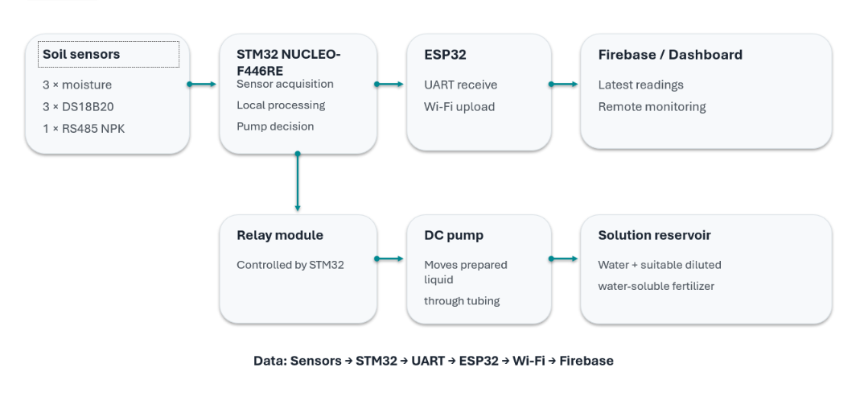
Figure 5.1: Block Diagram of the Proposed Methodology

5.2 Functional Blocks
Block | Main Function
Multi-depth soil sensing | Collect soil moisture measurements from three different depths.
Soil temperature sensing | Measure soil temperature at different depths using three DS18B20 sensors.
Nutrient sensing | Measure Nitrogen, Phosphorus and Potassium using an RS485-based NPK sensor.
Edge controller (STM32) | Acquire sensor readings, process data, compare moisture values with predefined thresholds and make irrigation decisions.
Communication unit (ESP32) | Receive sensor data from STM32 through UART and provide Wi-Fi connectivity for wireless monitoring.
Actuation stage | Operate the water pump automatically through a relay module based on the STM32 irrigation decision.
Web dashboard | Display soil moisture, temperature, NPK readings and irrigation system status through an HTTP-based interface.
5.3 Proposed Controller Arrangement
The proposed system uses an STM32 microcontroller as the primary edge controller for sensor acquisition, local processing and automatic irrigation control. It collects soil moisture measurements through the ADC interface, receives NPK measurements through the RS485 communication interface and acquires temperature readings from three DS18B20 sensors.
The STM32 processes the collected readings and compares soil moisture values against predefined threshold limits. When irrigation is required, the controller activates the relay module, which switches the DC water pump to supply water to the soil. When the required moisture condition is achieved, the controller switches the pump OFF according to the configured control logic.
An ESP32 module is connected to the STM32 through UART communication. It receives the sensor measurements and system information, establishes Wi-Fi connectivity and hosts an HTTP-based web server. The web dashboard retrieves the available data and displays the soil parameters and irrigation status for remote monitoring.
The division of responsibilities between the two controllers is summarized below:
Controller | Responsibilities
STM32 | Sensor data acquisition, local processing, threshold-based irrigation decisions and relay control.
ESP32 | UART data reception, Wi-Fi connectivity, HTTP web server and dashboard data delivery.
The system uses ADC for analog soil moisture measurements, UART/RS485 for NPK sensor communication, a digital interface for DS18B20 temperature sensors and GPIO for relay control.

CHAPTER 6

HARDWARE AND SOFTWARE IMPLEMENTATION

6.1 Hardware Components
Component | Role in the system | Details to confirm
STM32 controller | Main sensor acquisition and edge control | Exact STM32 board/model
ESP32 module | Wi-Fi communication and remote reporting | Exact ESP32 board/model
Soil-moisture sensors | Measure moisture at multiple depths | Sensor type and number of levels
Relay | Provides voltage to actuator | Relay Module
Micro Servo SG90 | Angular Position Control | Precise Angle Movement
EC sensor | Measure electrical conductivity | Sensor type and calibration method
Temperature sensor | Measure soil/ambient temperature | Exact model and placement
Pump and valves | Deliver irrigation water and nutrient solution | Voltage, current and driver ratings
Power supply | Provide regulated power to controller and loads | Voltage/current ratings and protection

6.1.1 STM32 Microcontroller

The STM32 microcontroller acts as the primary processing unit of the proposed system. It collects data from the connected soil sensors, processes the measured parameters, and performs local decision-making. Based on the sensor readings and predefined threshold values, it controls the irrigation and fertigation operations. Its processing capabilities make it suitable for implementing edge-based control.
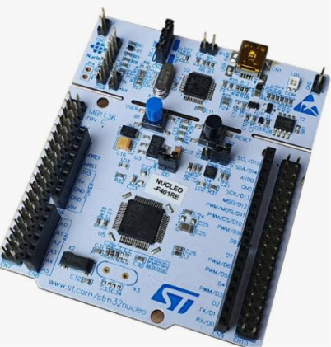

6.1.2 ESP32 Wi-Fi Module

The ESP32 is used as a wireless communication module in the proposed system. It transfers the collected soil parameters and system status to a remote monitoring dashboard through Wi-Fi connectivity. This allows users to monitor soil conditions and irrigation activities remotely.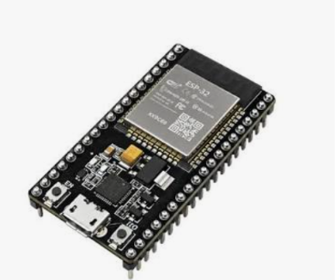

6.1.3 Capacitive Soil Moisture Sensor

Soil moisture sensors are used to measure the water content present in the soil. In this project, multiple sensors are placed at different soil depths to monitor moisture variations across the crop root zone. The collected readings help the controller determine whether irrigation is required.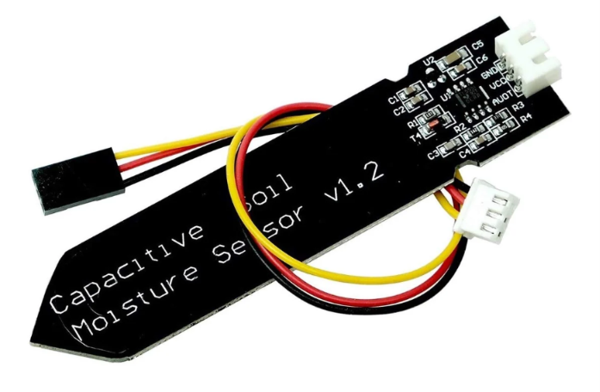

6.1.4 RS485 NPK Sensor

The NPK sensor measures the three major nutrients required for plant growth: Nitrogen (N), Phosphorus (P), and Potassium (K). It communicates with the controller through an RS485 interface. The measured nutrient values provide useful information about soil nutrient conditions and support appropriate fertigation decisions.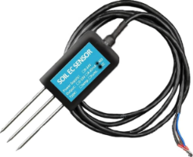

6.1.5 Temperature Sensors (DS18B20 – 3 Units)

The DS18B20 is a digital temperature sensor used to measure temperature at different soil depths. Three DS18B20 sensors can be installed at selected depth levels to observe temperature variations across the soil profile. These measurements provide additional information about soil conditions and help the controller analyse temperature changes along with moisture readings

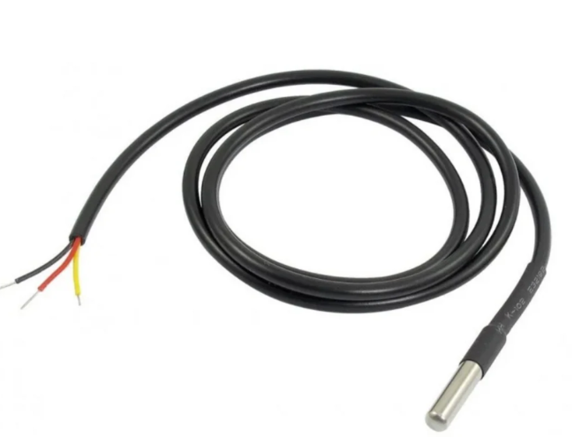

6.1.6 Relay Module

The relay module acts as an electrically controlled switching device. It allows the microcontroller to control external devices such as water pumps and solenoid valves. It provides an interface between the low-voltage controller signals and the actuator power circuits.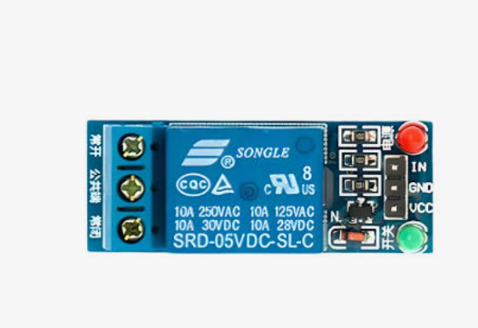

6.1.7 Power Supply

The power supply provides the required electrical energy to the microcontrollers, sensors, communication modules, and actuators. Appropriate voltage and current ratings are selected based on the requirements of each component to ensure reliable system operation
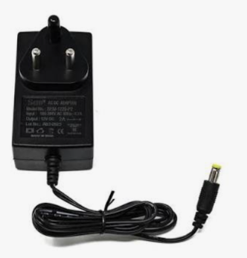

6.1.8 Pump and Tube
The pump is used to supply water to the agricultural soil whenever irrigation is required. It is controlled through a relay connected to the STM32 controller. Based on the soil-moisture readings collected from the three different depths, the STM32 makes the irrigation decision. When the moisture level falls below the predefined threshold, the controller activates the relay, which switches ON the pump and allows water to flow through the tube to the soil. When the required moisture condition is reached, the pump can be switched OFF. The tube carries water from the pump to the required irrigation area.
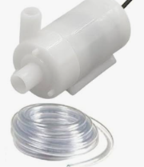

6.1.9 Micro Servo Motor (SG90)
The SG90 micro servo motor is used to provide controlled angular movement in the proposed irrigation system. It is connected to the controller and can be programmed to rotate to specific angular positions. The servo can be used for mechanical movement of the water-flow control arrangement, depending on the system design. This helps provide controlled operation of the irrigation mechanism.
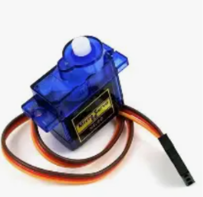

6.2. Sensor Interfacing
Analog sensors are connected to suitable ADC inputs after checking their output-voltage range against the controller limits. Digital sensors are connected through the interface specified by the manufacturer. The RS485 NPK sensor requires an RS485 transceiver between the differential bus and the controller UART. A common communication ground and suitable supply arrangement should be provided where required by the module design.

6.3 Multi-Depth Installation
The moisture sensors are installed at the selected soil depths, with each sensor assigned a unique channel or identifier in the firmware. The depth labels should be retained in the data structure so that the dashboard and control algorithm do not mix readings from different levels. Sensor positions should be documented with a simple installation diagram in the final report.

6.4 Embedded Software
The firmware is organized into initialization, sensor acquisition, data validation, filtering, decision-making, actuator control and communication tasks. A periodic sampling routine reads the sensors. The controller checks whether each value is within an acceptable range and marks missing or implausible readings as invalid. Valid readings are then passed to the control logic.

6.5 Data Processing
To reduce the effect of short-term fluctuations, the controller may use a moving average or median filter over a small number of samples. The filtered readings are associated with their depth labels and compared with configured limits. Thresholds should be selected after calibration and field observation.
6.6 Software code
6.6.1 STM32 Cube IDE
#include "main.h"
#include <stdio.h>
#include <string.h>
#include <stdint.h>
#include <stdlib.h>

extern ADC_HandleTypeDef hadc1;
extern UART_HandleTypeDef huart1;
extern UART_HandleTypeDef huart2;

/* NPK Modbus settings */
#define NPK_SLAVE_ID 1
#define NPK_START_REGISTER 0x001E
#define NPK_REGISTER_COUNT 3

/* Moisture calibration values.
Replace these after testing your actual sensors. */
#define MOISTURE_DRY_RAW 3500
#define MOISTURE_WET_RAW 1500

uint16_t moisture_5cm = 0;
uint16_t moisture_15cm = 0;
uint16_t moisture_25cm = 0;

int npk_n = -1;
int npk_p = -1;
int npk_k = -1;

uint16_t Read_ADC_Channel(uint32_t channel)
{
ADC_ChannelConfTypeDef sConfig = {0};

sConfig.Channel = channel;
sConfig.Rank = 1;
sConfig.SamplingTime = ADC_SAMPLETIME_84CYCLES;

if (HAL_ADC_ConfigChannel(&hadc1, &sConfig) != HAL_OK)
return 0;

HAL_ADC_Start(&hadc1);

if (HAL_ADC_PollForConversion(&hadc1, 100) != HAL_OK)
{
HAL_ADC_Stop(&hadc1);
return 0;
}

uint16_t value = HAL_ADC_GetValue(&hadc1);
HAL_ADC_Stop(&hadc1);

return value;
}

uint16_t Read_Moisture_Percentage(uint32_t channel)
{
uint16_t raw = Read_ADC_Channel(channel);

int percentage =
((int)MOISTURE_DRY_RAW - (int)raw) * 100 /
(MOISTURE_DRY_RAW - MOISTURE_WET_RAW);

if (percentage < 0) percentage = 0;
if (percentage > 100) percentage = 100;

return (uint16_t)percentage;
}

/* Modbus RTU CRC-16 */
uint16_t Modbus_CRC16(uint8_t *buffer, uint8_t length)
{
uint16_t crc = 0xFFFF;

for (uint8_t pos = 0; pos < length; pos++)
{
crc ^= buffer[pos];

for (uint8_t i = 0; i < 8; i++)
{
if (crc & 1)
crc = (crc >> 1) ^ 0xA001;
else
crc >>= 1;
}
}

return crc;
}

/* Read N, P and K from the RS-485 NPK sensor */
uint8_t Read_NPK_Sensor(void)
{
uint8_t request[8];
uint8_t response[11];

request[0] = NPK_SLAVE_ID;
request[1] = 0x03; // Read holding registers
request[2] = (NPK_START_REGISTER >> 8) & 0xFF;
request[3] = NPK_START_REGISTER & 0xFF;
request[4] = (NPK_REGISTER_COUNT >> 8) & 0xFF;
request[5] = NPK_REGISTER_COUNT & 0xFF;

uint16_t crc = Modbus_CRC16(request, 6);
request[6] = crc & 0xFF;
request[7] = (crc >> 8) & 0xFF;

/* Clear any old received bytes */
__HAL_UART_FLUSH_DRREGISTER(&huart1);

if (HAL_UART_Transmit(&huart1, request, 8, 500) != HAL_OK)
return 0;

/*
Allow the sensor time to process the request.
The response timeout is handled by HAL_UART_Receive.
*/
HAL_Delay(150);

if (HAL_UART_Receive(&huart1, response, 11, 1000) != HAL_OK)
return 0;

if (response[0] != NPK_SLAVE_ID ||
response[1] != 0x03 ||
response[2] != 6)
return 0;

uint16_t received_crc =
(uint16_t)response[9] |
((uint16_t)response[10] << 8);

uint16_t calculated_crc = Modbus_CRC16(response, 9);

if (received_crc != calculated_crc)
return 0;

npk_n = (response[3] << 8) | response[4];
npk_p = (response[5] << 8) | response[6];
npk_k = (response[7] << 8) | response[8];

return 1;
}

/* Send one CSV telemetry line to ESP32 */
void Send_To_ESP32(void)
{
char message[100];

snprintf(message, sizeof(message),
"DATA,%u,%u,%u,%d,%d,%d\r\n",
moisture_5cm,
moisture_15cm,
moisture_25cm,
npk_n,
npk_p,
npk_k);

HAL_UART_Transmit(&huart2,
(uint8_t *)message,
strlen(message),
1000);
}

6.6.2 ARDUINO IDE CODE

include <WiFi.h>
#include <WiFiClientSecure.h>
#include <HTTPClient.h>

// ---------------- WiFi DETAILS ----------------
const char* WIFI_SSID = "althaf";
const char* WIFI_PASSWORD = "12224444";

// ---------------- FIREBASE DETAILS ----------------

const char* FIREBASE_URL =

"https://soil-nutrient-profiling-default-rtdb.asia-southeast1.firebasedatabase.app";

const char* FIREBASE_PATH = "/Soil_Profile/latest.json";

// ---------------- UART CONFIGURATION ----------------

#define STM32_RX 16

#define STM32_TX 17

HardwareSerial STM32Serial(2);

// ---------------- VARIABLES ----------------

String receivedData = "";

unsigned long lastWiFiCheck = 0;

// ---------------- WIFI CONNECTION ----------------

void connectWiFi()

{

Serial.println();

Serial.print("Connecting to WiFi");

WiFi.begin(WIFI_SSID, WIFI_PASSWORD);

int attempts = 0;

while (WiFi.status() != WL_CONNECTED && attempts < 30)

{

delay(500);

Serial.print(".");

attempts++;

}

if (WiFi.status() == WL_CONNECTED)

{

Serial.println();

Serial.println("WiFi Connected!");

Serial.print("IP Address: ");

Serial.println(WiFi.localIP());

}

else

{

Serial.println();

Serial.println("WiFi Connection Failed!");

}

}

// ---------------- FIREBASE UPLOAD ----------------

void uploadToFirebase(String jsonData)

{

if (WiFi.status() != WL_CONNECTED)

{

Serial.println("WiFi not connected. Upload skipped.");

return;

}

WiFiClientSecure client;

// For prototype testing only.

client.setInsecure();

HTTPClient http;

String url = String(FIREBASE_URL) + FIREBASE_PATH;

http.begin(client, url);

http.addHeader("Content-Type", "application/json");

http.setTimeout(10000);

Serial.println();

Serial.println("Uploading data to Firebase...");

int httpResponseCode = http.PUT(jsonData);

if (httpResponseCode > 0)

{

Serial.print("Firebase Response: ");

Serial.println(httpResponseCode);

if (httpResponseCode == 200)

{

Serial.println("Data uploaded successfully!");

}

else

{

Serial.println("Firebase upload returned an error.");

Serial.println(http.getString());

}

}

else

{

Serial.print("Upload Error: ");

Serial.println(http.errorToString(httpResponseCode));

}

http.end();

}

// ---------------- SETUP ----------------

void setup()

{

Serial.begin(115200);

// UART2 communication with STM32

STM32Serial.begin(

115200,

SERIAL_8N1,

STM32_RX,

STM32_TX

);

Serial.println();

Serial.println("MULTI-DEPTH SOIL NUTRIENT PROFILING");

Serial.println("----------------------------------");

connectWiFi();

Serial.println();

Serial.println("Waiting for STM32 data...");

}

// ---------------- MAIN LOOP ----------------

void loop()

{

// Reconnect WiFi if disconnected

if (WiFi.status() != WL_CONNECTED)

{

if (millis() - lastWiFiCheck > 10000)

{

lastWiFiCheck = millis();

connectWiFi();

}

}

// Receive data from STM32

while (STM32Serial.available())

{

char incomingChar = STM32Serial.read();

if (incomingChar == '\n')

{

receivedData.trim();

if (receivedData.length() > 0)

{

Serial.println();

Serial.println("Data received from STM32:");

Serial.println(receivedData);

// Check that received data is JSON

if (receivedData.startsWith("{") &&

receivedData.endsWith("}"))

{

uploadToFirebase(receivedData);

}

else

{

Serial.println("Invalid JSON format!");

}

receivedData = "";

}

}

else

{

if (receivedData.length() < 2048)

{

receivedData += incomingChar;

}

else

{

Serial.println("UART data too long. Clearing buffer.");

receivedData = "";

}

}

}

CHAPTER 7

EDGE-ADAPTIVE FERTIGATION ALGORITHM

7.1 Operating Principle

The proposed system operates by monitoring soil conditions at three different depths using soil moisture sensors and DS18B20 temperature sensors. An RS485-based NPK sensor is also used to measure the nitrogen, phosphorus and potassium levels in the soil.

The STM32 microcontroller acts as the primary edge controller, responsible for collecting sensor readings, processing the measured values and making irrigation control decisions. The soil moisture readings from different depths are evaluated against predefined threshold limits to identify irrigation requirements.

Based on the processed moisture measurements, the STM32 controls the relay module to operate the DC water pump. When the soil moisture condition indicates a requirement for irrigation, the relay activates the pump to supply water through the connected tubing. The pump is switched OFF when the required moisture condition is achieved.

The ESP32 module receives sensor information from the STM32 through UART communication and provides Wi-Fi connectivity for remote monitoring through the web dashboard.

This integration of multi-depth soil sensing, local embedded processing and automatic water control supports efficient soil monitoring and irrigation management.

7.2 Algorithm

Power ON the system and initialize the STM32, ESP32 and required communication interfaces.

Read the soil moisture sensors installed at the three different depths.

Acquire temperature measurements from the DS18B20 sensors.

Obtain NPK measurements from the RS485-based NPK sensor.

Check the availability and validity of the received sensor readings.

Process the collected measurements and compare the soil moisture values with predefined threshold limits.

Determine whether irrigation is required based on the moisture conditions at the monitored soil depths.

If irrigation is required, activate the relay module to switch ON the DC water pump.

Continue monitoring the soil moisture readings during irrigation.

Switch OFF the pump when the configured moisture condition is achieved.

Transfer the available sensor readings and irrigation status from STM32 to ESP32 through UART.

Display the latest available measurements and system status on the web dashboard through Wi-Fi.

Repeat the monitoring and decision-making cycle continuously

Table 7.1 Illustrative Decision Table

Condition | Controller Response
Moisture below the configured threshold at the relevant soil depth | Identify irrigation requirement and activate the pump through the relay.
Moisture reaches the configured acceptable condition | Switch OFF the irrigation pump.
Moisture is within the acceptable range | Keep the irrigation pump OFF.
NPK readings indicate variations in nutrient levels | Display the measurements for soil nutrient assessment.
Temperature readings vary across soil depths | Display the corresponding depth-wise temperature measurements.
Sensor reading is invalid or unavailable | Identify the affected reading as invalid and avoid using it for an unreliable control decision.
Wi-Fi communication is unavailable | Maintain local irrigation control through STM32; remote monitoring may be temporarily unavailable.

7.4 Edge-Based Irrigation Control

The term edge-based control refers to performing the irrigation decision-making process locally using the STM32 microcontroller rather than depending entirely on a remote server or cloud platform.

In the proposed system, the STM32 evaluates the soil moisture measurements collected from different depths and compares them with predefined threshold values. Based on the configured irrigation conditions, the controller determines whether the pump should be switched ON or OFF.

The local decision-making process allows the irrigation system to continue operating even when Wi-Fi connectivity is unavailable. The ESP32 is responsible for wireless data communication and dashboard monitoring, while the STM32 independently performs the primary irrigation control operation.

The use of multi-depth soil measurements provides a better understanding of moisture distribution across the monitored soil profile. This supports more informed irrigation decisions compared with systems that rely only on a single soil moisture measurement.

7.4 Edge-Based Irrigation Control

The term edge-based control refers to performing the irrigation decision-making process locally using the STM32 microcontroller rather than depending entirely on a remote server or cloud platform.

In the proposed system, the STM32 evaluates the soil moisture measurements collected from different depths and compares them with predefined threshold values. Based on the configured irrigation conditions, the controller determines whether the pump should be switched ON or OFF.

The local decision-making process allows the irrigation system to continue operating even when Wi-Fi connectivity is unavailable. The ESP32 is responsible for wireless data communication and dashboard monitoring, while the STM32 independently performs the primary irrigation control operation.

CHAPTER 8

TESTING, RESULTS AND DISCUSSION
8.1 Results
8.1.1 Hardware Implementation Results
The proposed smart irrigation system was designed to monitor soil conditions at multiple depths and support automated irrigation based on real-time sensor measurements. The system integrates multi-depth soil moisture monitoring, soil temperature measurement and NPK nutrient monitoring with an STM32-based edge controller.
The multi-depth soil monitoring approach helps identify variations in moisture and temperature across different soil layers. The NPK sensor provides information about the nitrogen, phosphorus and potassium levels in the soil, supporting soil nutrient assessment.
Based on the collected sensor data, the STM32 controller evaluates soil moisture conditions and determines the irrigation requirements using predefined threshold limits. The relay module controls the DC water pump to supply water according to the controller's decision.
The ESP32 communication module provides Wi-Fi connectivity for transferring sensor readings to the web dashboard, allowing users to remotely monitor soil conditions and irrigation status.
The major outcomes of the proposed system include:
- Multi-depth monitoring of soil moisture at three different depths.
- Measurement of soil temperature using DS18B20 sensors.
- Monitoring of nitrogen, phosphorus and potassium levels using an RS485 NPK sensor.
- Identification of variations in soil conditions across different soil depths.
- Automated irrigation decisions based on soil moisture measurements.
- Local edge-based processing and pump control using the STM32 microcontroller.
- Remote monitoring of soil parameters and irrigation status through the ESP32-based web dashboard.
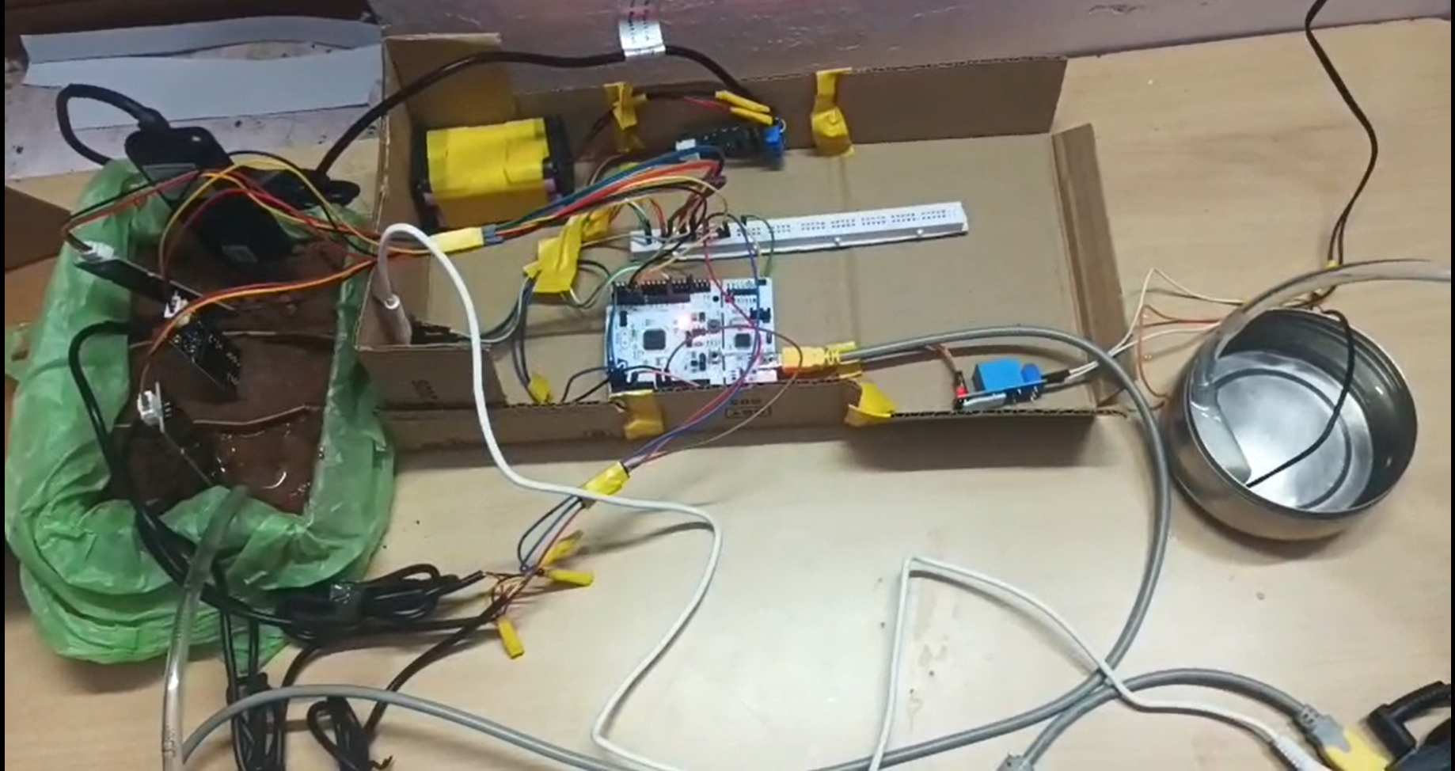
Fig 8.1.1 Hardware prototype of the multi-depth soil monitoring and irrigation system.
8.1.2 . Web dashboard displaying readings from different soil depths
The developed web dashboard successfully presents the collected soil measurements in an organized graphical interface. The overview section displays the average soil moisture, average soil temperature and current water pump status.
The nutrient profiling section displays the measured nitrogen, phosphorus and potassium values.
Table 8.1: NPK Measurement Results
Nutrient | Measured Value
Nitrogen (N) | 125 mg/kg
Phosphorus (P) | 46 mg/kg
Potassium (K) | 91 mg/kg
The dashboard also displays the irrigation status. In the captured screenshot, the water pump is indicated as ON, showing that the relay-controlled irrigation output is activated.
The Firebase connection status is displayed as connected, indicating successful synchronization of monitoring data with the database at the time of capture.
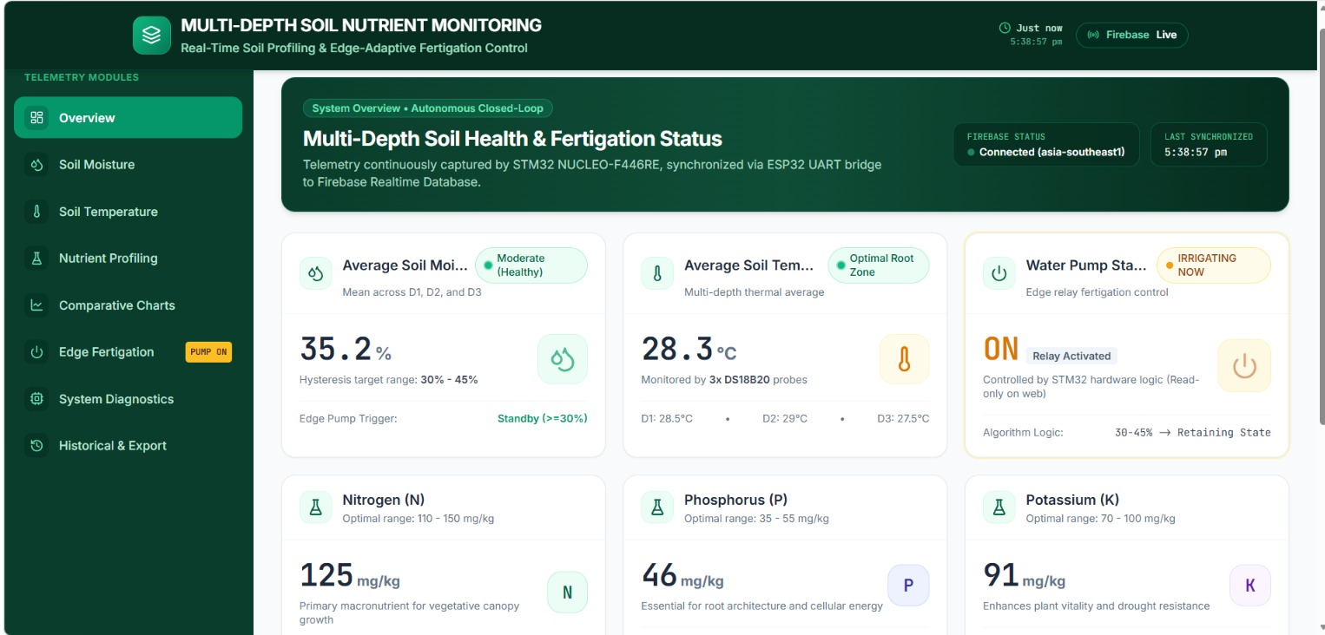
Fig. 8.1.2. Web dashboard displaying readings from different soil depths

8.1.3 Firebase Realtime Database integration
The Firebase Realtime Database is used to store and synchronize the soil monitoring data received from the ESP32 communication module. The STM32 collects and processes the sensor measurements, which are transferred to the ESP32 through UART communication. The ESP32 then communicates with Firebase using Wi-Fi connectivity.
The database organizes the collected information under the Soil_Profile node. The latest child node contains the most recently received sensor measurements, including:
- Average soil moisture.
- Soil moisture values at three different depths (D1, D2 and D3).
- Soil temperature values at the corresponding depths.
- Number of connected DS18B20 temperature sensors.
The database provides a centralized location for accessing the latest soil monitoring information. The updated measurements can be retrieved by the web dashboard to display the current soil conditions.
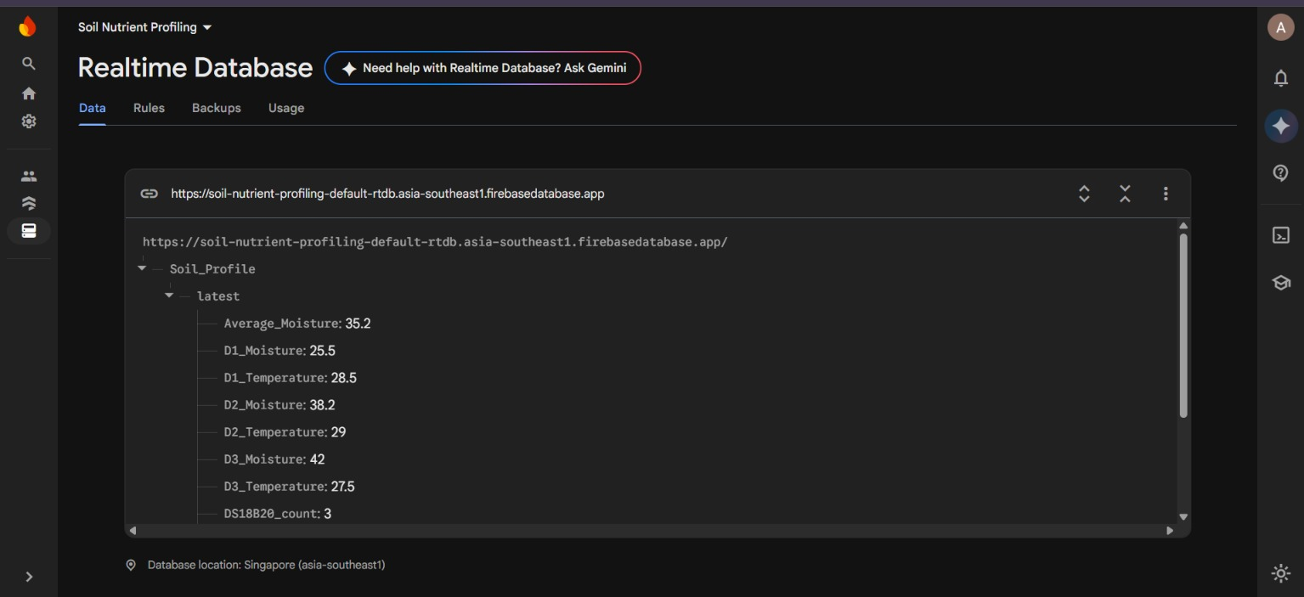
Fig. 8.1.3 Firebase Realtime Database for synchronisation of data

8.2 Discussion
The proposed system provides an integrated approach to precision agriculture by combining multi-depth soil monitoring with edge-based irrigation control. Unlike conventional irrigation systems that mainly depend on surface-level moisture measurements or fixed watering schedules, the proposed approach considers soil moisture conditions at multiple depths.
The use of multiple soil parameters provides a broader understanding of the soil profile. The three soil moisture sensors help identify variations in water availability across different layers, while the DS18B20 sensors provide corresponding temperature measurements. The RS485-based NPK sensor provides additional information about soil nutrient levels, supporting better soil assessment.
The STM32 microcontroller performs local sensor processing and threshold-based irrigation decision-making. This enables the system to control the water pump independently of continuous internet connectivity. The relay module acts as the switching interface between the controller and the pump.

Furthermore, the ESP32 communication module enables wireless data transfer and remote monitoring through the web dashboard. Users can observe the latest available soil measurements and irrigation status without directly accessing the field monitoring unit.
Overall, the proposed system demonstrates the potential to improve irrigation management through multi-depth sensing, local decision-making and wireless monitoring. The integration of embedded processing and automated water control supports efficient water utilization and provides a foundation for further development of intelligent precision agriculture systems.

CHAPTER 9

CONCLUSION AND FUTURE SCOPE

9.1 Conclusion
This project presents the design and development of a multi-depth soil nutrient profiling system with edge-based irrigation control. The proposed system integrates soil moisture monitoring at different depths, soil temperature measurement and NPK nutrient monitoring with an STM32-based edge controller.
The multi-depth monitoring approach provides information about variations in soil moisture and temperature across different soil layers. The RS485-based NPK sensor provides measurements of nitrogen, phosphorus and potassium levels, supporting soil nutrient assessment.
The STM32 microcontroller performs local processing and makes irrigation decisions by comparing the measured soil moisture values with predefined threshold limits. Based on these decisions, the relay module controls the DC water pump to supply water when required. The ESP32 communication module enables wireless data transfer and remote monitoring through the web dashboard.
The system combines multi-depth sensing, embedded processing, automatic irrigation and wireless monitoring to support efficient water management and informed soil assessment. Further calibration and field testing can help evaluate its performance under different soil and environmental conditions.

9.2 Future Scope
The proposed system can be enhanced in the following ways:
- Crop-specific profiles: Introduce crop-specific moisture thresholds and growth-stage-based operating limits for improved irrigation decisions.
- Advanced dashboard: Develop depth-wise graphical trends, alerts and historical data visualization.
- Data logging: Maintain long-term records to study seasonal variations in soil moisture, temperature and nutrient levels.
- Nutrient recommendation: Introduce a validated nutrient recommendation model using NPK measurements, soil-test results and agronomic guidelines.
- Solar-powered operation: Integrate solar panels and battery monitoring to support deployment in remote agricultural fields.
- Multi-zone irrigation: Extend the system to multiple agricultural zones with independently controlled irrigation valves.
- Future fertigation capability: Integrate a suitable fertilizer delivery mechanism with validated nutrient requirements and safety controls.
- Improved edge intelligence: Explore advanced data analysis and adaptive control techniques to improve irrigation decisions using historical sensor measurements.

CHAPTER 10

REFERENCES
[1] Food and Agriculture Organization of the United Nations (FAO), publications and technical resources on irrigation water management and sustainable soil management. https://www.fao.org/
[2] FAO, “The State of the World’s Land and Water Resources for Food and Agriculture,” FAO, Rome. Consult the edition used by the project team.
[3] World Bank, resources on climate-smart agriculture and water management. https://www.worldbank.org/
[4] Espressif Systems, “ESP32 Technical Reference Manual” and ESP-IDF documentation. https://docs.espressif.com/
[5] STMicroelectronics, STM32 reference manuals and HAL/LL documentation for the exact controller used. https://www.st.com/
[6] Modbus Organization, “MODBUS over Serial Line Specification and Implementation Guide,” for RS485/Modbus communication where applicable. https://www.modbus.org/
[7] Datasheet and user manual of the exact RS485 NPK sensor used in the prototype. [Add manufacturer, model and revision.]
[8] Datasheet and calibration instructions for the soil-moisture sensors used. [Add manufacturer and model.]
[9] Datasheet and calibration instructions for the pH and EC sensor modules used. [Add manufacturer and model.]
[10] Datasheets for the pump, solenoid valves and driver modules used in the prototype. [Add manufacturer and model.]

